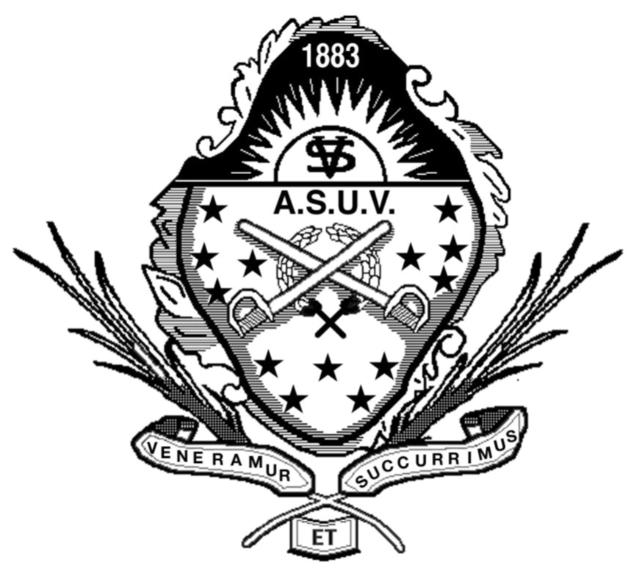 Antietam Auxiliary No. 3

Auxiliary to Sons of

Union Veterans of the Civil War

Media Release

HEADLINE – IN BOLD – MUST BE CATCHY, INTERESTING AND STRONG!

EVENT TOWN, STATE (Date of release in civilian style, e.g. August 10, 2018) – Lead paragraph is the key part of the release. Make sure it briefly includes: WHO did it?, WHAT did they do?, WHERE did they do it?, WHEN did they do it?, WHY did they do it?, HOW did they do it? Many of these points can be included in one or two sentences.

The subsequent paragraph(s) expand on the lead and be the point where you tell the story. The body of the media release is important to prioritize messages from the most important to the least important. Use short sentences and short paragraphs with vigorous, active language. Do not use organization-specific colloquialisms – write for the understanding of the general public. Always write in the third person. Use spell-check AND proofread – do BOTH. Use quotes to make your writing more interesting but remember all assertions opinions must be attributed to a particular person, or the organization. The media are unable to use newsworthy assertions unless sourced, and they will often call to check on the quotes.

-30-

(Always include the “-30-“ It is a journalistic symbol indicating the body of the release is concluded;
“-ends-“ or “###” is also acceptable)

Media contact: Your Full Name, Position in the organization; phone number: xxx-xxx-xxxx email: xxxx@xxx.com BE AVAILABLE – PROMPTLY RETURN ALL CALLS AND EMAILS

Consider using the following (or similarly styled descriptor) as a boiler-plate in the footer. It provides organizational information to the journalist that is not necessarily needed in the body of the release. Italicize it:

Antietam Auxiliary #3 is a member auxiliary of the Department of the Chesapeake, Auxiliary to Sons of Union Veterans of the Civil War (ASUVCW), serving its home base of Frederick, Maryland, but also includes Clarksville, Gaithersburg, Hagerstown, Huntingtown, Mt. Airy, and Timonium Maryland; Northern Virginia; and West Virginia. The ASUVCW, organized in 1883, is a fraternal, non-profit organization dedicated to preserving the history and legacy of heroes who fought and worked to save the Union. For more information on Antietam Auxiliary #3, please visit: http://antietam-asuvcw.org/.

