Auxiliary to Sons of Union Veterans of the Civil War

Press Media Guide

August 3, 2018

Version History
Version | Description of Version | Author/Editor | Date Completed
0.1 | Draft | Rosemary Martin | Aug 01 2018
1.0 | Final – Added Approval | Rosemary Martin | Aug 03 2018

Approval Review History
Version | Description of Version | Reviewer | Date Completed
0.1 | Reviewed/Approved | Rosemary Martin | Aug 02 2018
0.1 | Reviewed/Approved | Ramona Greenwalt | Aug 03 2018

Final Approval History
Version | Description of Version | Approver | Date Completed
1.0 | Verbally Approved Per Phone Conversation Aug 3 2018 | Ramona Greenwalt | Aug 03 2018

Table of Contents
Introduction 4
Section 1. Instructional Guidelines 4
Section 2. One-Page Fact Sheet 7
Section 3. Department Media Release 8
Section 4. Member Auxiliary Media Release - 1 9
Section 5. Member Auxiliary Media Release – 2 10
Section 6. Member Auxiliary Release Example 11
Section 7. Networks: Lakeway Publishers 12
Section 8. Approval by National Auxiliary 15

Introduction
The purpose of this document is to assist both Member and Department Auxiliaries in press correspondence.
There neither is any intention to make this an all-encompassing guide nor an attempt designed to address every possible media-related interaction. Nevertheless, this will give you a good starting point in building a solid long-term relationship. Remember, even if your event only attracts a handful of attendees, the media allows us to reach a huge number of folks with our message – for free!
Recognition goes to SUVCW Brother Faron Taylor, whose both work and volunteer experience required regular interaction with the press, who provided the baseline and templates for this document.
This is a living document that may change with each Press Correspondent successor.

Instructional Guidelines
Establishing a good relationship with the media is an effective tool in promoting the tenets of our Order and attracting and holding community interest. However, in building this relationship it is important to remember that very, very few of our activities are seen by the media as “news.” Most often media coverage of our events is considered public service and covered as “feature” stories. Always keep the following in mind: newsprint, air time, even online media, and other press correspondence venues are at a premium amount, and newsworthy items, rather than public service stories, typically demand the most attention. This leaves us competing with every other community organization for limited coverage. Make the most of it!

Regardless of the level of sophistication of the media in your area, the work of our Order demands nothing less than a professional effort on our part, and that includes media interaction. If forced to choose between covering two community stories, as one where the local group is disorganized or one where the group is well-prepared, one can guess which event will most often get the most attention.

Below are several tips on how to “be prepared” and make the most of the public relations benefit media can provide.

- Make a contact list of all the media in your area:
  - Newspapers
  - Radio
  - Television
  - Other Contacts

If your Auxiliary is in a rural area with one local paper, chances are you will know the newspaper's editor or staff reporter(s) by name. If not, this is your first network to build. If you live in a larger metropolitan area, there may be dozens of newspapers, dailies, weeklies, etc. In either case, expect there to be turnover in staffing. Seek out the email address and other contact information for the outlet’s assignment editor and take the time to introduce yourself. Do this not when you have an upcoming event but now! Keep the contact list current.

- Find out each outlet’s requirements and deadlines for submission of “Media Advisories” and “Media Releases” and stick to them.

- Do not assume a more distant media outlet will have no interest in your event. While they may not send a correspondent, they may incorporate it into a story on an event more local to them. Additionally, they may (at their discretion) post the story onto one of the wire service feeds. If so, you have hit the jackpot!

- Always follow up a Media Advisory with a courteous reminder on the eve of your event. Never ask the media to commit to coverage.

- Develop a one-page “Fact Sheet” about our Order. Section 2 contains a sample for consideration.

- Assemble a “Media Packet” that includes printed copies of the Media Advisory, Media Release, and the “Fact Sheet” of our Order. (In most cases it will be possible to prepare and have at-the-ready your Auxiliary’s Media Release in advance of the event.) Introduce yourself and hand this to the media as they arrive for the event. Doing so helps minimize the chance for erroneous information being reported by a correspondent who may have zero background on the event, who we are, what we do, etc. Most, if not all of the pertinent information will be in the release and they will be VERY appreciative. Always make sure to send out a copy to each media outlet the Advisory was sent afterward, (including those who attended – paper gets lost).

- Lastly, any factors may preclude the Sister in charge of running the event from coordinating with on-site media. Things such as setting up public address systems, greeting dignitaries, etc. at the risk of overlooking the media is inviting trouble. Determine in advance the need for someone whose sole task is handling the media.

One-Page Fact Sheet
As noted in Section 1, below is an example of a one-page fact sheet.

Department Media Release
Below is an example of a Media Release to be submitted at the Department level.

Member Auxiliary Media Release - 1
Below is a sample of a media release to be provided from the Member or Subordinate Auxiliary.

Member Auxiliary Media Release – 2
Below is another sample of a media release with a longer optional footer, to be provided from the Member or Subordinate Auxiliary.

Member Auxiliary Release Example
Below is a media release example template for a Member Auxiliary.

Networks: Lakeway Publishers

Lakeway Publishers owns and operates community newspapers in Tennessee; however, their media, both digital and hardcopy, reach a nationwide audience:

Camp Chase Gazette
P.O. Box 625
Morristown, TN 37814
Phone: 1.800.624.0281 Ext 460
Fax: 423.581.3061
Email: ctcirsm@lcs.net
___________________________________________________________________________
Citizens Companion
P.O. Box 625
Morristown, TN 37814
Phone: 1-800-624-5281 Ext 460
FAX: 423-581-3061
www.citizenscompanion.com

The Civil War Courier
The Civil War Courier
P.O. Box 625
Morristown, TN 37814
Phone: 1.800.624.0281 Ext 460
Fax: 423.581.3061
www.civilwarcourier.com
___________________________________________________________________
Lakewood Publishers also connects with www.civilwarmarketplace.com.
Upon a search for Sons of Union Veterans of the Civil War, the only Sons of Union Veterans found was:
Abraham Lincoln Camp 100 Civil War Roundtable 609-448-6355
Sons of Union Veterans of the Civil War Hightstown, NJ 08520

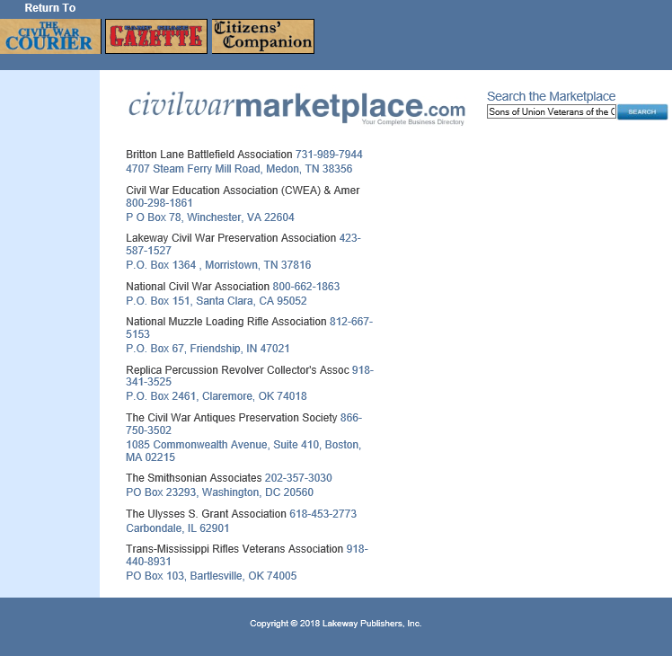

In using the below URL, Rosemary Martin, 2017-2018 Press Correspondent, sent a message to the “Contact Us” mailbox:

July 23, 2018 7:58 PM – Contact via
http://www.campchase.com/contact-us/
Camp Chase Gazette
P.O. Box 625
Phone: 1.800.624.0281 Ext 460
Fax: 423.581.3061
Email: ctcirsm@lcs.net
Subject: Civil War Ancestry - Union - asuvcw.org advertisement
How does my non-profit, all volunteer organization, Auxiliary to Sons of Union Veterans of the Civil War (ASUVCW), www.asuvcw.org, submit announcements, recruitment invitations, events, advertisements, etc. with you? Is there a cost? Thank you.

On follow-up July 24, 2018, Rosemary Martin called 1.800.624.0281 Ext 460 and spoke with Penny who informed her that Lakewood Publishers has a veteran event listing calendar, and it is FREE!
So, send your events to Penny at cwc1861@lcs.net!

Approval by National Auxiliary

Signature of National ASUVCW 2017-2018 President:
Ramona Greenwalt Date: August 3, 2018
Ramona Greenwalt
Phone – Digital Signature

Signature of National ASUVCW 2017-2018 Secretary/Treasurer:
Rachelle Campbell Date: _August 3, 2018
Rachelle Campbell
Digital Signature

Signature of 2017-2018 Originating ASUVCW Press Correspondent:
Rosemary S. Martin Date: August 3, 2018
Rosemary S. Martin
Digital Signature

Signature of the National Press Correspondent - Update:
Rosemary S. Martin Date: August 3, 2018
Rosemary S. Martin
Digital Signature

